Multiple Response

$NSSF_Awareness Frequencies
 |  | Responses |  | Percent of Cases
 |  | N | Percent | Percent of Cases
NSSF Awareness Sourcesª | Radio | 5 | 13.5% | 50.0%
NSSF Awareness Sourcesª | TV | 3 | 8.1% | 30.0%
NSSF Awareness Sourcesª | Newspaper | 5 | 13.5% | 50.0%
NSSF Awareness Sourcesª | Friends_Relatives_Colleagues | 4 | 10.8% | 40.0%
NSSF Awareness Sourcesª | Publicity_Boards | 5 | 13.5% | 50.0%
NSSF Awareness Sourcesª | Employer | 6 | 16.2% | 60.0%
NSSF Awareness Sourcesª | Visiting_NSSF_Premises | 5 | 13.5% | 50.0%
NSSF Awareness Sourcesª | Other_Specify | 4 | 10.8% | 40.0%
Total |  | 37 | 100.0% | 370.0%

a. Dichotomy group tabulated at value 0.

Frequencies

Statistics
 |  | Radio | TV | Newspaper | Friends_Relatives_Colleagues | Publicity_Boards | Employer
N | Valid | 10 | 10 | 10 | 10 | 10 | 10
N | Missing | 0 | 0 | 0 | 0 | 0 | 0

Statistics
 |  | Visiting_NSSF_Premises | Other_Specify
N | Valid | 10 | 10
N | Missing | 0 | 0

Frequency Table

Radio
 |  | Frequency | Percent | Valid Percent | Cumulative Percent
Valid | Yes | 5 | 50.0 | 50.0 | 50.0
Valid | No | 5 | 50.0 | 50.0 | 100.0
Valid | Total | 10 | 100.0 | 100.0

TV
 |  | Frequency | Percent | Valid Percent | Cumulative Percent
Valid | Yes | 3 | 30.0 | 30.0 | 30.0
Valid | No | 7 | 70.0 | 70.0 | 100.0
Valid | Total | 10 | 100.0 | 100.0

Newspaper
 |  | Frequency | Percent | Valid Percent | Cumulative Percent
Valid | Yes | 5 | 50.0 | 50.0 | 50.0
Valid | No | 5 | 50.0 | 50.0 | 100.0
Valid | Total | 10 | 100.0 | 100.0

Friends_Relatives_Colleagues
 |  | Frequency | Percent | Valid Percent | Cumulative Percent
Valid | Yes | 4 | 40.0 | 40.0 | 40.0
Valid | No | 6 | 60.0 | 60.0 | 100.0
Valid | Total | 10 | 100.0 | 100.0

Publicity_Boards
 |  | Frequency | Percent | Valid Percent | Cumulative Percent
Valid | Yes | 5 | 50.0 | 50.0 | 50.0
Valid | No | 5 | 50.0 | 50.0 | 100.0
Valid | Total | 10 | 100.0 | 100.0

Employer
 |  | Frequency | Percent | Valid Percent | Cumulative Percent
Valid | Yes | 6 | 60.0 | 60.0 | 60.0
Valid | No | 4 | 40.0 | 40.0 | 100.0
Valid | Total | 10 | 100.0 | 100.0

Visiting_NSSF_Premises
 |  | Frequency | Percent | Valid Percent | Cumulative Percent
Valid | Yes | 5 | 50.0 | 50.0 | 50.0
Valid | No | 5 | 50.0 | 50.0 | 100.0
Valid | Total | 10 | 100.0 | 100.0

Other_Specify
 |  | Frequency | Percent | Valid Percent | Cumulative Percent
Valid | Yes | 4 | 40.0 | 40.0 | 40.0
Valid | No | 6 | 60.0 | 60.0 | 100.0
Valid | Total | 10 | 100.0 | 100.0

Bar Chart

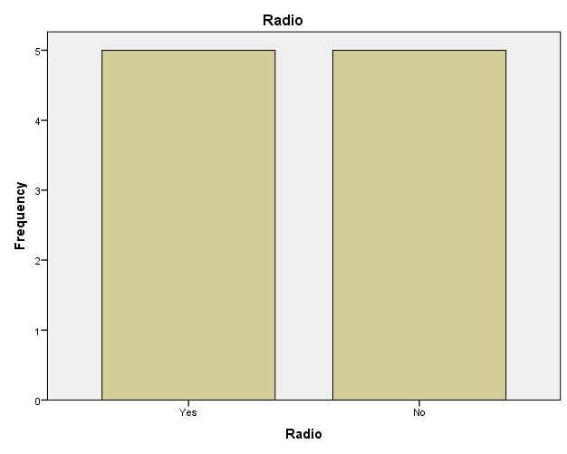

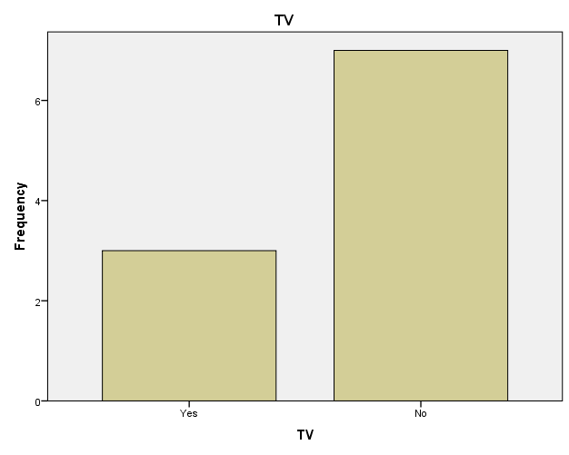

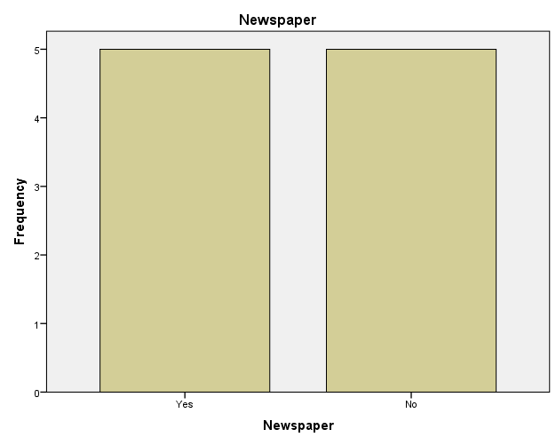

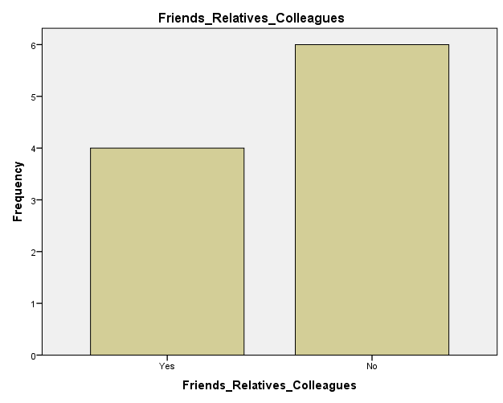

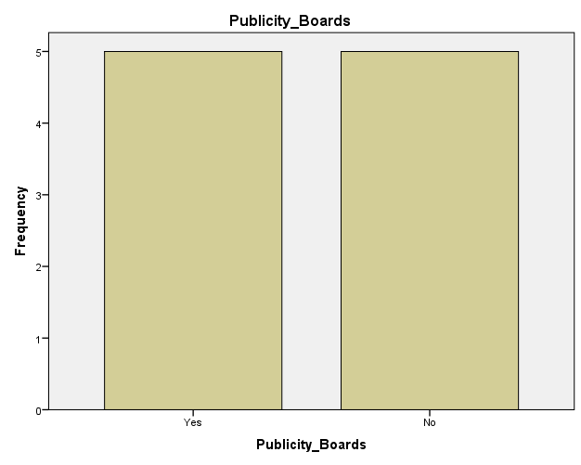

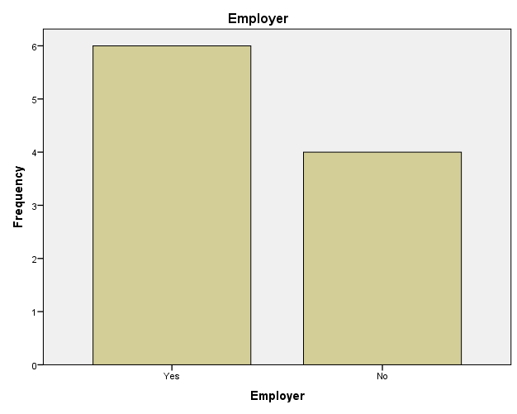

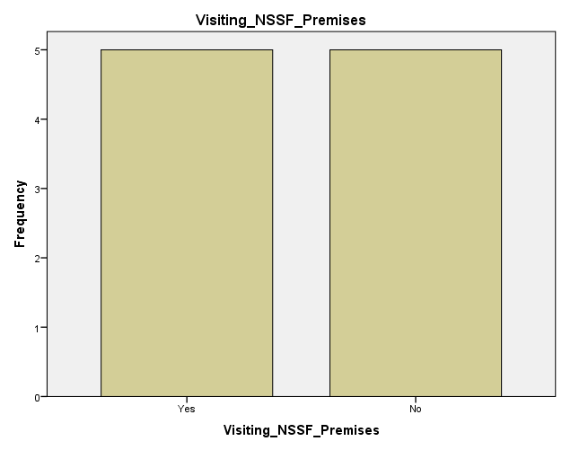

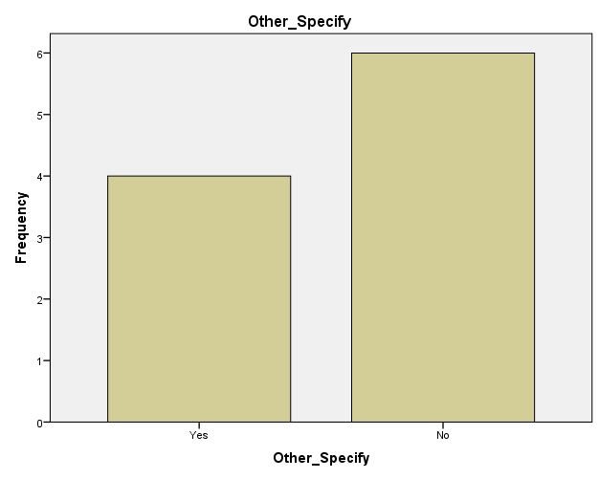

Frequencies

Frequency Table

Gender
 |  | Frequency | Percent | Valid Percent | Cumulative Percent
Valid | Male | 6 | 60.0 | 60.0 | 60.0
Valid | Female | 4 | 40.0 | 40.0 | 100.0
Valid | Total | 10 | 100.0 | 100.0

Age in Years
 |  | Frequency | Percent | Valid Percent | Cumulative Percent
Valid | 18-24 | 1 | 10.0 | 10.0 | 10.0
Valid | 25-34 | 3 | 30.0 | 30.0 | 40.0
Valid | 35-44 | 2 | 20.0 | 20.0 | 60.0
Valid | 45-54 | 1 | 10.0 | 10.0 | 70.0
Valid | 55+(and Over) | 3 | 30.0 | 30.0 | 100.0
Valid | Total | 10 | 100.0 | 100.0

Occupation
 |  | Frequency | Percent | Valid Percent | Cumulative Percent
Valid | Employed | 3 | 30.0 | 30.0 | 30.0
Valid | Self Employed | 3 | 30.0 | 30.0 | 60.0
Valid | Claimant | 4 | 40.0 | 40.0 | 100.0
Valid | Total | 10 | 100.0 | 100.0

Relationship to contributor
 |  | Frequency | Percent | Valid Percent | Cumulative Percent
Valid | Self | 3 | 30.0 | 30.0 | 30.0
Valid | Family Member | 3 | 30.0 | 30.0 | 60.0
Valid | Friend | 4 | 40.0 | 40.0 | 100.0
Valid | Total | 10 | 100.0 | 100.0

Region (Customer Location)
 |  | Frequency | Percent | Valid Percent | Cumulative Percent
Valid | Nairobi | 3 | 30.0 | 30.0 | 30.0
Valid | Rift Valley | 3 | 30.0 | 30.0 | 60.0
Valid | Central/Eastern | 2 | 20.0 | 20.0 | 80.0
Valid | Nyanza/Western | 1 | 10.0 | 10.0 | 90.0
Valid | Coast/North Eastern | 1 | 10.0 | 10.0 | 100.0
Valid | Total | 10 | 100.0 | 100.0

NSSF's benefits awareness
 |  | Frequency | Percent | Valid Percent | Cumulative Percent
Valid | Age/Retirement Benefit | 2 | 20.0 | 20.0 | 20.0
Valid | Survival Benefit | 4 | 40.0 | 40.0 | 60.0
Valid | Invalidity Benefit | 2 | 20.0 | 20.0 | 80.0
Valid | Funeral Graft | 2 | 20.0 | 20.0 | 100.0
Valid | Total | 10 | 100.0 | 100.0

Distribution of NSSF offices in the country
 |  | Frequency | Percent | Valid Percent | Cumulative Percent
Valid | Disatisfied | 3 | 30.0 | 30.0 | 30.0
Valid | Neutral | 2 | 20.0 | 20.0 | 50.0
Valid | Satisfied | 2 | 20.0 | 20.0 | 70.0
Valid | Very satisfied | 2 | 20.0 | 20.0 | 90.0
Valid | Don't Know/Not Applicable | 1 | 10.0 | 10.0 | 100.0
Valid | Total | 10 | 100.0 | 100.0

Registration process
 |  | Frequency | Percent | Valid Percent | Cumulative Percent
Valid | Very Disatisfied | 2 | 20.0 | 20.0 | 20.0
Valid | Disatisfied | 1 | 10.0 | 10.0 | 30.0
Valid | Neutral | 4 | 40.0 | 40.0 | 70.0
Valid | Satisfied | 2 | 20.0 | 20.0 | 90.0
Valid | Very Satisfied | 1 | 10.0 | 10.0 | 100.0
Valid | Total | 10 | 100.0 | 100.0

Modes of contribution to NSSF
 |  | Frequency | Percent | Valid Percent | Cumulative Percent
Valid | Very Disatisfied | 3 | 30.0 | 30.0 | 30.0
Valid | Disatisfied | 3 | 30.0 | 30.0 | 60.0
Valid | Neutral | 2 | 20.0 | 20.0 | 80.0
Valid | Satisfied | 2 | 20.0 | 20.0 | 100.0
Valid | Total | 10 | 100.0 | 100.0

Affordability of contribution to NSSF
 |  | Frequency | Percent | Valid Percent | Cumulative Percent
Valid | Very Disatisfied | 3 | 30.0 | 30.0 | 30.0
Valid | Disatisfied | 1 | 10.0 | 10.0 | 40.0
Valid | Neutral | 2 | 20.0 | 20.0 | 60.0
Valid | Satisfied | 1 | 10.0 | 10.0 | 70.0
Valid | Very Satisfied | 1 | 10.0 | 10.0 | 80.0
Valid | Don't Know/Not Applicable | 2 | 20.0 | 20.0 | 100.0
Valid | Total | 10 | 100.0 | 100.0

Contribution I make shall enable sufficient income in the end
 |  | Frequency | Percent | Valid Percent | Cumulative Percent
Valid | Very Disatisfied | 2 | 20.0 | 20.0 | 20.0
Valid | Disatisfied | 1 | 10.0 | 10.0 | 30.0
Valid | Neutral | 3 | 30.0 | 30.0 | 60.0
Valid | Satisfied | 3 | 30.0 | 30.0 | 90.0
Valid | Very Satisfied | 1 | 10.0 | 10.0 | 100.0
Valid | Total | 10 | 100.0 | 100.0

Safety of contributions made to NSSF
 |  | Frequency | Percent | Valid Percent | Cumulative Percent
Valid | Very Disatisfied | 2 | 20.0 | 20.0 | 20.0
Valid | Disatisfied | 2 | 20.0 | 20.0 | 40.0
Valid | Neutral | 2 | 20.0 | 20.0 | 60.0
Valid | Satisfied | 3 | 30.0 | 30.0 | 90.0
Valid | Very Satisfied | 1 | 10.0 | 10.0 | 100.0
Valid | Total | 10 | 100.0 | 100.0

The Investments made by NSSF using our contribution
 |  | Frequency | Percent | Valid Percent | Cumulative Percent
Valid | Very Disatisfied | 2 | 20.0 | 20.0 | 20.0
Valid | Disatisfied | 2 | 20.0 | 20.0 | 40.0
Valid | Neutral | 2 | 20.0 | 20.0 | 60.0
Valid | Satisfied | 2 | 20.0 | 20.0 | 80.0
Valid | Very Satisfied | 1 | 10.0 | 10.0 | 90.0
Valid | Don't Know/Not Applicable | 1 | 10.0 | 10.0 | 100.0
Valid | Total | 10 | 100.0 | 100.0

NSSF's benefits compared to that of competitors
 |  | Frequency | Percent | Valid Percent | Cumulative Percent
Valid | Disatisfied | 3 | 30.0 | 30.0 | 30.0
Valid | Neutral | 2 | 20.0 | 20.0 | 50.0
Valid | Satisfied | 2 | 20.0 | 20.0 | 70.0
Valid | Very Satisfied | 1 | 10.0 | 10.0 | 80.0
Valid | Don't Know/Not Applicable | 2 | 20.0 | 20.0 | 100.0
Valid | Total | 10 | 100.0 | 100.0

Decisions and rules exercised by NSSF staff
 |  | Frequency | Percent | Valid Percent | Cumulative Percent
Valid | Very Disatisfied | 1 | 10.0 | 10.0 | 10.0
Valid | Disatisfied | 3 | 30.0 | 30.0 | 40.0
Valid | Neutral | 4 | 40.0 | 40.0 | 80.0
Valid | Satisfied | 2 | 20.0 | 20.0 | 100.0
Valid | Total | 10 | 100.0 | 100.0

NSSF does not tolerate corrupt activities
 |  | Frequency | Percent | Valid Percent | Cumulative Percent
Valid | Disagree | 2 | 20.0 | 20.0 | 20.0
Valid | Neither agree nor disagree | 3 | 30.0 | 30.0 | 50.0
Valid | Agree | 2 | 20.0 | 20.0 | 70.0
Valid | Strongly Agree | 1 | 10.0 | 10.0 | 80.0
Valid | Don't Know/Not Applicable | 2 | 20.0 | 20.0 | 100.0
Valid | Total | 10 | 100.0 | 100.0

NSSF staff new better ways of service delivery
 |  | Frequency | Percent | Valid Percent | Cumulative Percent
Valid | Disagree | 3 | 30.0 | 30.0 | 30.0
Valid | Neither agree nor disagree | 1 | 10.0 | 10.0 | 40.0
Valid | Agree | 3 | 30.0 | 30.0 | 70.0
Valid | Strongly Agree | 1 | 10.0 | 10.0 | 80.0
Valid | Don't Know/Not Applicable | 2 | 20.0 | 20.0 | 100.0
Valid | Total | 10 | 100.0 | 100.0

NSSF staff act responsibly and openly in day to day work
 |  | Frequency | Percent | Valid Percent | Cumulative Percent
Valid | Strongly Disagree | 2 | 20.0 | 20.0 | 20.0
Valid | Disagree | 1 | 10.0 | 10.0 | 30.0
Valid | Neither agree nor disagree | 3 | 30.0 | 30.0 | 60.0
Valid | Agree | 3 | 30.0 | 30.0 | 90.0
Valid | Strongly Agree | 1 | 10.0 | 10.0 | 100.0
Valid | Total | 10 | 100.0 | 100.0

NSSF staff work together when necessary to meet my needs
 |  | Frequency | Percent | Valid Percent | Cumulative Percent
Valid | Strongly Disagree | 1 | 10.0 | 10.0 | 10.0
Valid | Disagree | 1 | 10.0 | 10.0 | 20.0
Valid | Neither agree nor disagree | 4 | 40.0 | 40.0 | 60.0
Valid | Agree | 2 | 20.0 | 20.0 | 80.0
Valid | Strongly Agree | 1 | 10.0 | 10.0 | 90.0
Valid | Don't Know/Not Applicable | 1 | 10.0 | 10.0 | 100.0
Valid | Total | 10 | 100.0 | 100.0

Bar Chart

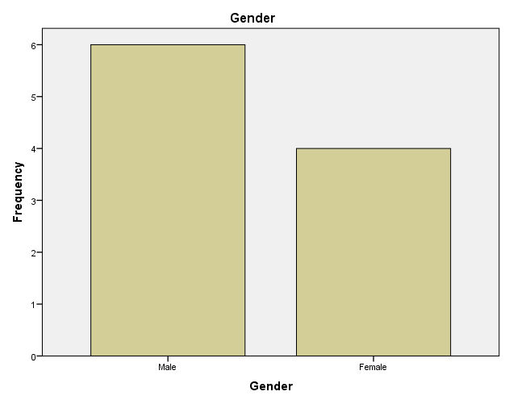

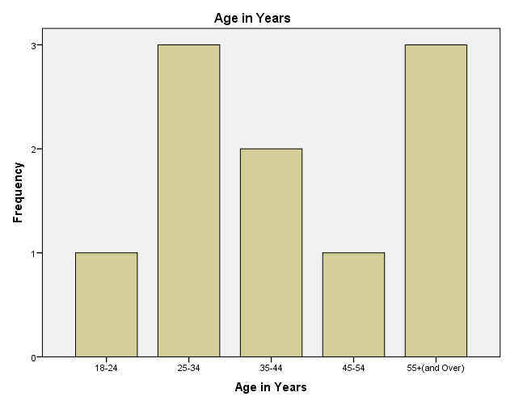

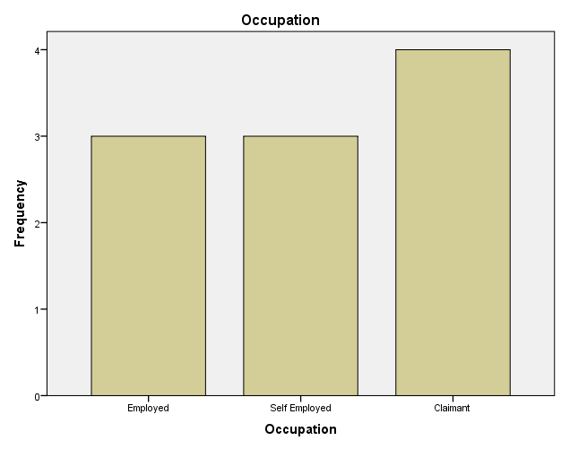

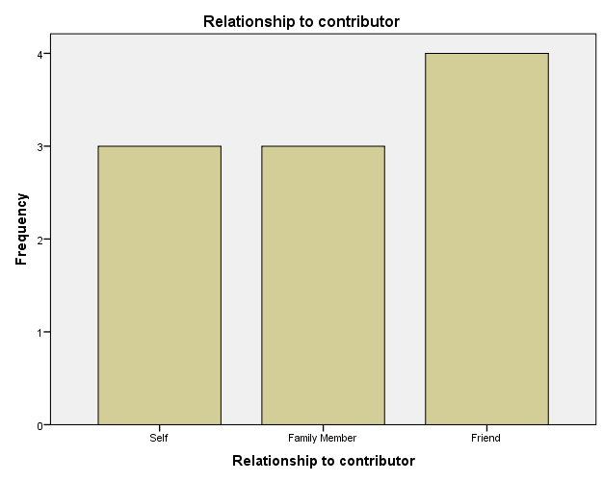

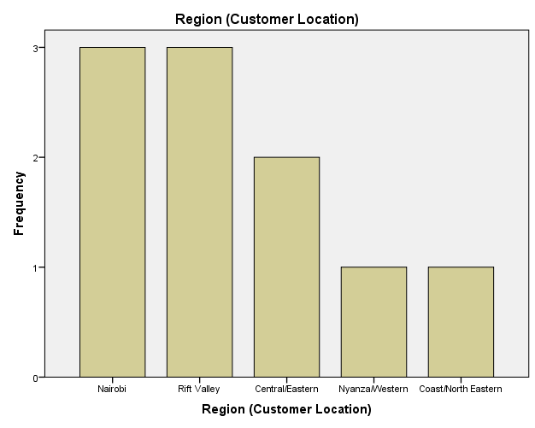

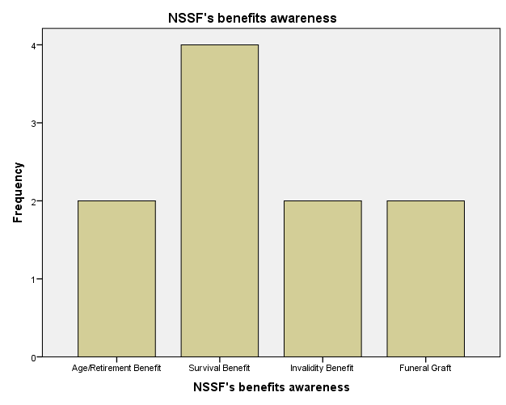

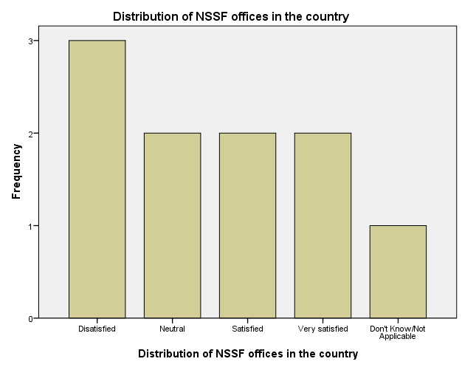

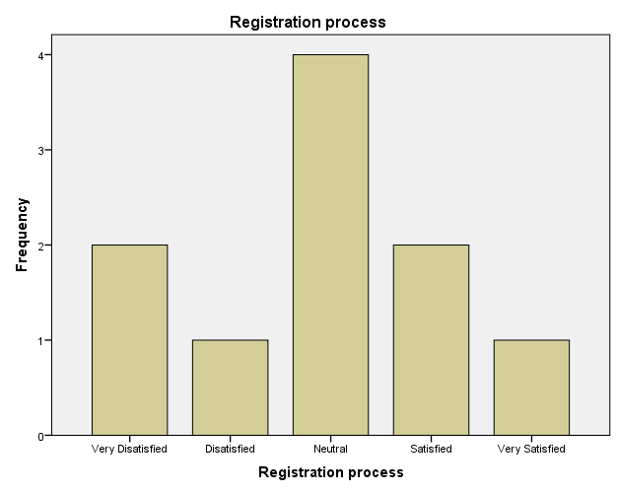

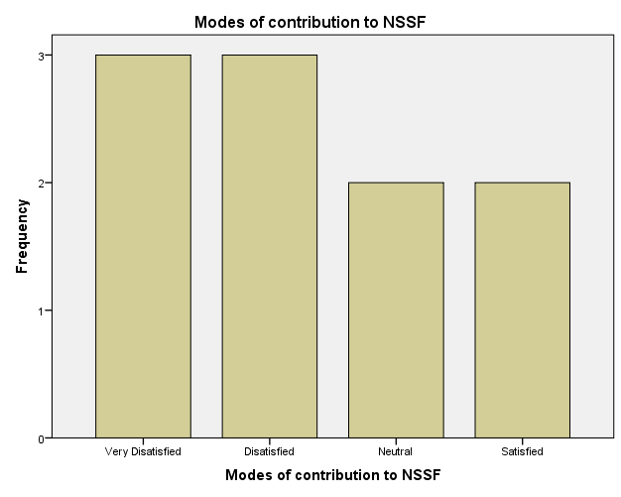

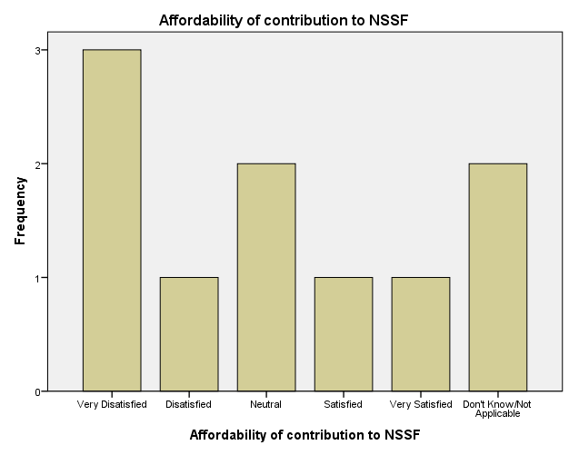

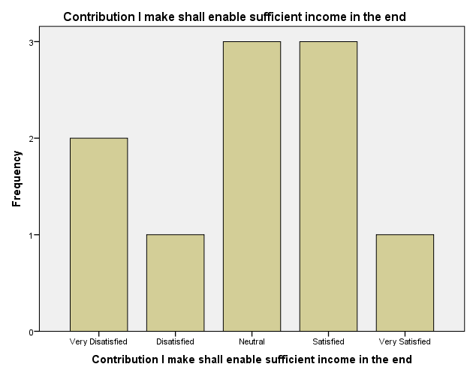

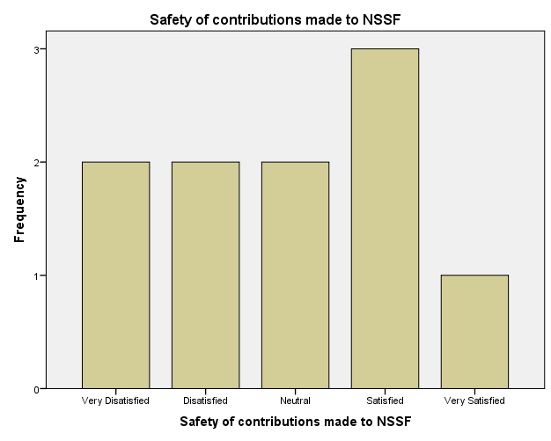

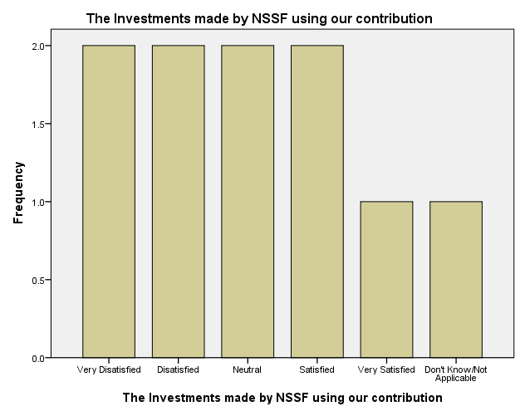

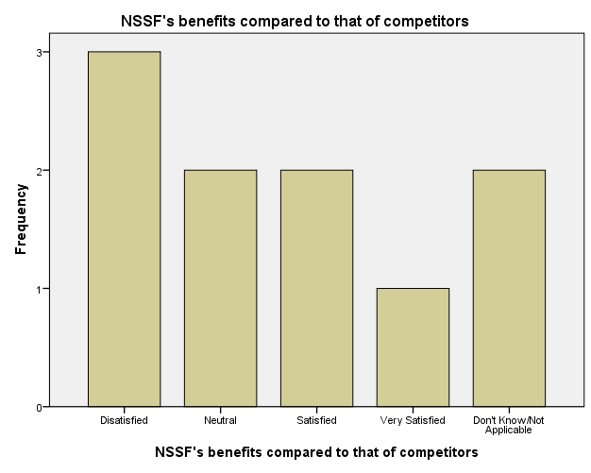

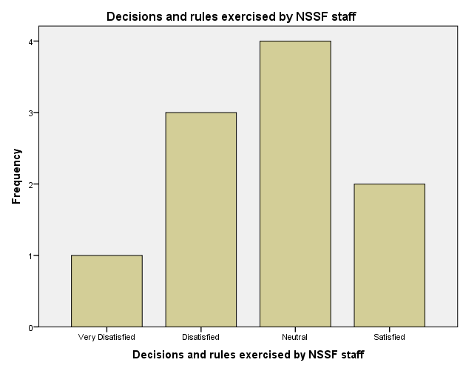

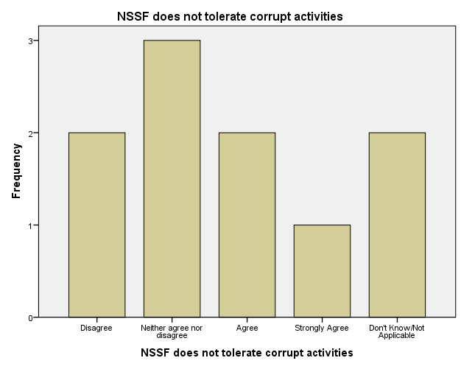

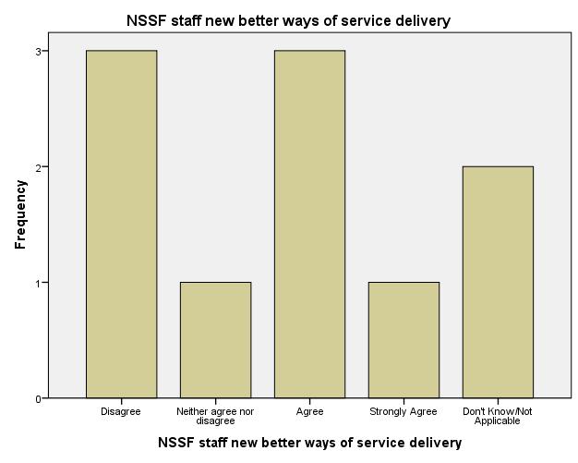

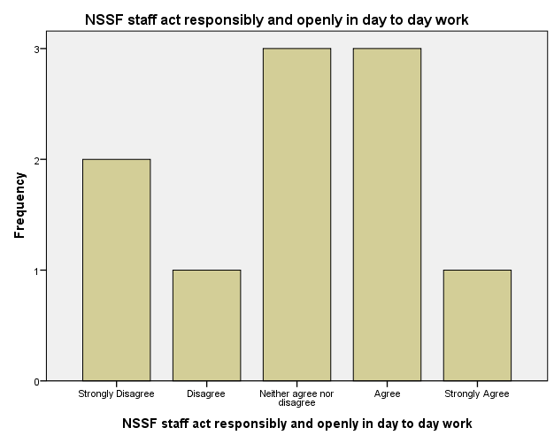

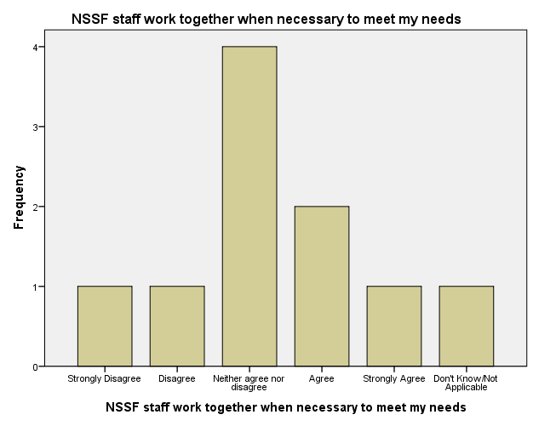

SAVE OUTFILE='C:\Users\Rodgers\Desktop\Kenneth _Data Responses_Data.sav'
/COMPRESSED.

